

თბილისის თავისუფალი უნივერსიტეტი

კომპიუტერული მეცნიერებების, მათემატიკისა და ინჟინერიის სკოლა (MACS[E])

ელექტრო და კომპიუტერული ინჟინერიის პროგრამა

ჯავახიშვილი ნონია
კვეტენაძე საბა

ელექტრო და კომპიუტერული ინჟინერიის ლაბორატორია - პროექტის ანგარიში

ლეგოს ავტომატური დამხარისხებელი

თბილისი
2026

Free University of Tbilisi
School of Mathematics, Computer Science and Engineering (MACS[E])
Electronic and Computer Engineering Program

Javakhishvili Nonia
Kvetenadze Saba

Electronic and Computer Engineering Laboratory - Project Report

Automatic Lego Sorter

Tbilisi
2026

Annotation

Automated material sorting is a fundamental process in modern industrial automation, traditionally requiring high-end computational hardware and expensive vision systems. This project explores the feasibility of executing robust computer vision and electromechanical sorting using low-cost embedded microcontrollers. We designed and implemented an automated LEGO brick sorting system capable of classifying objects by shape and color using three microcontroller distributed architecture. The hardware integrates an ESP32-CAM as a remote vision sensor node streaming JPEG frames over HTTP, a ESP32 CYD (Cheap Yellow Display) featuring a touch controller to handle real-time user interface inputs and a master esp-32 which handles sorting logic and stepper movement.
The physical sorting mechanism utilizes a custom-geared conveyor belt triggered by multiple Infrared (IR) beam-break sensors in an array, and a 5-bucket symmetrical rotating carousel indexed by NEMA 17 stepper motor and A4988 driver. The power architecture features a 12V DC primary supply, a step-down buck converter for logic levels, and an isolated power delivery line for the ESP32-CAM to prevent high-torque motor switching noise from degrading analog sensor readings. The embedded vision pipeline executes a dual-pass geometric classification algorithm combining theoretical area infill ratios with contour vertex counting.
Under controlled conditions, the system achieved a sorting accuracy upwards of approximately 85%, processing one LEGO brick every 5 seconds (a throughput of 12 bricks per minute). Key challenges, including shape sorting inaccuracy was successfully mitigated implementing dual-condition algorithmic evaluations to resolve edge-case geometrical ambiguities.

ანოტაცია

მასალების ავტომატიზებული დახარისხება თანამედროვე ინდუსტრიული ავტომატიზაციის ფუნდამენტურ პროცესს წარმოადგენს, რაც ტრადიციულად მოითხოვს მძლავრ გამოთვლით ტექნიკასა და ძვირადღირებულ ხედვის სისტემებს. მოცემული პროექტი იკვლევს სანდო კომპიუტერული ხედვისა და ელექტრომექანიკური დახარისხების განხორციელების შესაძლებლობას დაბალბიუჯეტიანი მიკროკონტროლერების გამოყენებით. პროექტის ფარგლებში შეიქმნა LEGO-ს დეტალების დამხარისხებელი ავტომატიზებული სისტემა, რომელსაც შეუძლია ობიექტების კლასიფიკაცია ფორმისა და ფერის მიხედვით და მათი განაწილება სამმაგი მიკროკონტროლერის არქიტექტურის გამოყენებით. აპარატურა აერთიანებს ESP32-CAM-ს, როგორც ხედვის სენსორს რომელიც გადასცემს JPEG კადრებს HTTP-ის საშუალებით, ასევე იყენებს ESP32 CYD-ს (Cheap Yellow Display)სენსორული ეკრანით, რომელიც უზრუნველყოფს მომხმარებლის ინტერფეისს და ასევე იყენებს მთავარ esp-32 რომელიც წარმართავს სორტირების ლოგიკას და სტეპერების მოძრაობას.
დამხარისხებელი ფიზიკური მექანიზმი იყენებს კონვეიერის ლენტს, რომელიც აქტიურდება რამოდენიმე ინფრაწითელი (IR) სენსორის მეშვეობით, და 5-სექციიან მბრუნავ „კარუსელს“, რომლის პოზიციონირება ხორციელდება NEMA 17 საფეხურებრივი ძრავითა (Stepper motor) და A4988 დრაივერით. სისტემის სტაბილურობის უზრუნველსაყოფად, კვების არქიტექტურა მოიცავს 12V DC ძირითად წყაროს, ძაბვის დამწევ (Buck) კონვერტერს ლოგიკური დონეებისთვის და იზოლირებულ კვების ხაზს ESP32-CAM-სთვის, რათა თავიდან იქნას აცილებული ძრავების მუშაობით გამოწვეული არასტაბილური კვება. ჩაშენებული კომპიუტერული ხედვის ალგორითმი ახდენს გეომეტრიულ კლასიფიკაციას ფართობის შევსების კოეფიციენტისა და კონტურის წვეროების დათვლის კომბინირებით.
კონტროლირებად პირობებში სისტემამ მიაღწია დახარისხების 85%-იან სიზუსტეზე მეტს, ერთ LEGO-ს დეტალზე 5 წამის დახარჯვით (წუთში 12 დეტალი). ძირითადი გამოწვევები, როგორიცაა ფორმის მიხედვით სორტირების სირთულეები წარმატებით გადაიჭრა განათების მოდიფიკაციითა და ალგორითმში ორმაგი პირობითი შეფასების ინტეგრაციით, რამაც მინიმუმამდე დაიყვანა გეომეტრიული ცდომილებები.

Table of contents
Annotation 3
ანოტაცია 4
Table of contents 5
Technical Overview 6
Problem and Context 6
Applied Methods & Technologies 6
Distributed Network and Power Architecture 7
Sensors and Electromechanical Indexing 7
Embedded Computer Vision and Algorithmic Logic 8
Experimental Results & Evaluation 9
Skills 10
System Visuals & Architecture 11
GitHub 12
Conclusion 13
Bibliography 14
Appendices 15

Technical Overview

Problem and Context
The automated sorting of physical materials based on visual characteristics is a cornerstone of modern industrial manufacturing, recycling, and logistics. Traditionally, these sorting tasks rely on centralized industrial computers processing data from expensive, high-definition camera arrays. This paradigm restricts the adoption of automation in small-scale, cost-sensitive, or mobile applications. The primary challenge addressed in this project is demonstrating the capability to perform highly reliable electromechanical sorting and computer vision strictly at the edge, relying exclusively on heavily constrained embedded microcontrollers.
By building a LEGO brick sorter driven entirely by ESP32 microcontrollers, this project highlights the optimization needed to capture images, process pixel arrays, deduce geometric properties, and precisely actuate stepper motors. The inherent challenges involve overcoming limited RAM, dealing with signal noise generated by electromechanical actuators, compensating for ambient light inconsistencies, and achieving real-time communication between multiple independent embedded devices.

Applied Methods & Technologies
The system consists of two primary architectural domains: Hardware/Actuation and Distributed Embedded Vision.

Distributed Network and Power Architecture
The system processing load is distributed across three separate ESP32 microcontrollers interacting wirelessly:
- ESP32 TFT (CYD - Cheap Yellow Display): Acts as the interactive user interface node. It drives the integrated TFT screen using the TFT_eSPI library over a dedicated VSPI bus, reads user touch inputs via an XPT2046 resistive touch controller, renders dynamic control menus, and sends operational modes and bucket configurations directly to the main controller.
- ESP32 Master Controller: Serves as the central state machine and motion control hub. It monitors the beam-break sensor array, coordinates timing sequences, and outputs step and direction signals to the motor drivers. The ESP32 TFT and ESP32 Master communicate wirelessly using the low-latency ESP-NOW protocol.
- ESP32-CAM: Operates as a remote vision sensor node executing an HTTP JPEG streaming server to capture and send 160x120 pixel resolution frames over HTTP for downstream image processing.
To ensure electrical stability against current surges and inductive kickback from motor coils, a modular power architecture was implemented. A primary 12V DC power supply directly powers the NEMA 17 stepper motor drivers (A4988). A high-efficiency DC-DC buck converter steps this 12V supply down to 5V to power the main ESP32 microcontrollers. Crucially, the ESP32-CAM receives power through an isolated daughterboard routing directly from a separate supply. This isolated topology prevents severe transient voltage drops caused by stepper motor switching from corrupting the ESP32-CAM's analog-to-digital converter (ADC) during frame capture and triggering unexpected brownout resets.
Sensors and Electromechanical Indexing
Object arrival detection relies on an array of three active-LOW Infrared (IR) beam-break sensors mounted across the conveyor path. The conveyor belt is driven by a NEMA 17 stepper motor. When a LEGO brick interrupts the IR beam array, the main ESP32 Master immediately halts the conveyor, holding the brick stationary so the camera can capture a clear, unblurred frame over HTTP.
For output categorization, a 5-bucket symmetrical carousel is indexed by a second NEMA 17 stepper motor. With 5 equal divisions, the indexing angle required to advance by one bucket position is calculated as: 360 degrees / 5 = 72 degrees

On a standard 1.8 degrees per step motor operating in full-step mode, this angle translates precisely to 40 steps per bucket shift.
Embedded Computer Vision and Algorithmic Logic
Captured raw RGB565 frames are processed dynamically in the ESP32's PSRAM. To eliminate background noise from the dark belt surface, a luminance and saturation thresholding filter applies color limits (Red + Green + Blue <= 60, Value >= 35%, and Saturation >= 28%).
Shape classification utilizes a dual-pass evaluation metric:
- Pass 1 (Area Infill Ratio): The extracted pixel blob area (objCount) is compared against three ideal geometric bounding models:
  - Ideal bounding rectangle area
  - Ideal circumscribed circle area = (pi / 4) * vertical diameter * horizontal diameter
  - Ideal maximum triangle area (derived from extreme cardinal boundary points)
- Pass 2 (Contour and Corner Extraction): To resolve geometric ambiguities where area ratios alone are insufficient, the algorithm traces the object perimeter and evaluates internal corner angles. By taking adjacent edge segments as directional vectors, the system calculates the internal angle using the vector dot product formula (dividing the dot product of the vectors by the product of their magnitudes).
A valid vertex is registered whenever the corner angle exceeds 50 degrees. A final decision voting mechanism combines the total vertex count (4 = Rectangle, 3 = Triangle, less than 3 = Circle) with the area infill ratio to accurately classify the object's geometry.

Experimental Results & Evaluation
Through rigorous testing, the prototype demonstrated an overall sorting accuracy upwards of approximately 85%. Operational speed stabilized at 1 brick processed every 5 seconds, yielding a continuous throughput of 12 bricks per minute.
During experimentation, a critical failure mode emerged due to specular light reflections off the glossy rubber conveyor belt. This was mitigated by not using the implemented led lights on esp-cam holder. Instead to solve this algorithm was tuned to operate exclusively under ambient, diffused room lighting. Additionally, ambiguous shape classifications (e.g., distinguishing an angled rectangle from a triangle) were successfully suppressed by the implementation of the dual-pass area-and-vertex vote system, which heavily reduced false positives.

Skills
This project required the integration of various hardware and software disciplines:
- Programming Languages: C++, Embedded C.
- Microcontrollers & Architecture: ESP32 (Main Controller), ESP32-CAM (Vision Node), ESP32 CYD (Cheap Yellow Display).
- Software Frameworks & Libraries: Arduino Core for ESP32, TFT_eSPI (Display Drivers), AccelStepper (Motor Profiling), TJpg_Decoder (Image Processing), WiFiUDP (Network Communication).
- Development Toolchains: Arduino IDE, Visual Studio Code (VS Code), PlatformIO.
- Actuation & Motor Control: NEMA 17 Stepper Motors, A4988 Stepper Drivers, Hardware PWM (LEDC), Precision Gearing Mechanisms.
- Power Electronics: DC-DC Buck Converters, Logic Level Isolation, Voltage Regulation.
- Sensors: Active-LOW Infrared (IR) Beam-Break Array.
- CAD & Modeling: Autodesk Fusion 360 (for mechanism design and 1:1 layout replication).

System Visuals & Architecture

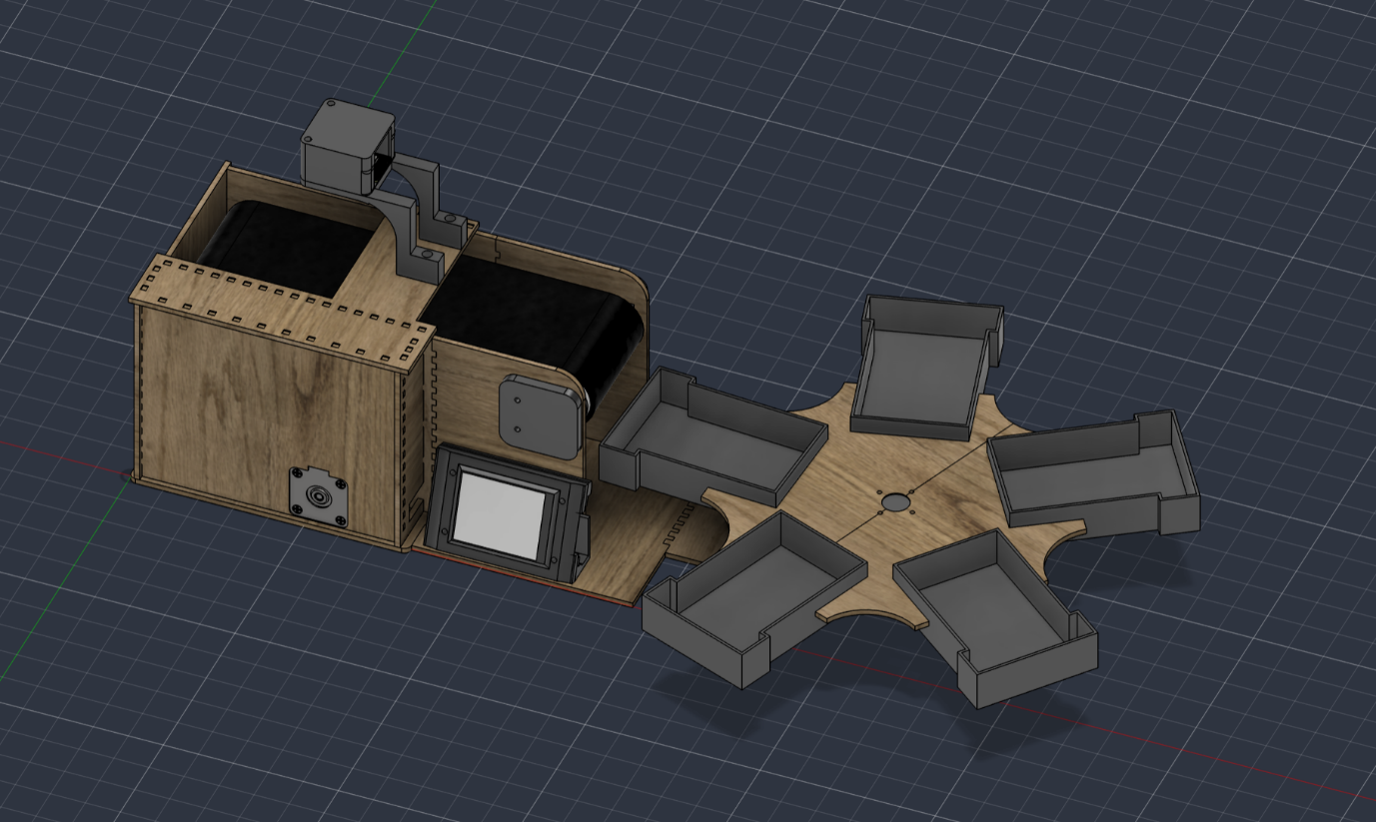
Fusion 360 model of the LEGO sorter

GitHub
The entire source code, library dependencies, and CAD assets are documented in a public GitHub repository.
- Repository Link: https://github.com/nno433/LEGO-Sorter.git
- Structure:
  - /src: Contains vision_sorter.ino (Slave logic) and master.ino (CYD UI logic).
  - /lib: Contains custom dependencies.
  - /cad: Contains Autodesk Fusion 360 .f3d files, .dxf files for laser cutting plywood and exported .stl files for 3D printing.
  - README.md: Includes detailed description.

Conclusion
This project successfully established a highly capable, localized electromechanical sorting mechanism relying purely on low-cost microcontrollers. By achieving an 85% sorting accuracy and a 12-brick-per-minute throughput, the system validates the premise that heavy industrial tasks can be adapted for edge-computing environments with proper algorithmic optimizations.
The project was a deeply collaborative effort. Nonia Javakhishvili led the physical hardware prototyping, structural mechanics, electromechanical assembly (steppers and gearing), and the robust isolated power delivery architecture. Saba Kvetenadze directed the software architecture, engineering the embedded C++ vision pipeline, the dual-pass geometric math, implemented the wireless communication protocols,and the dynamic CYD touchscreen interface.
Future iterations of this system could implement automated feeding and dropper mechanism.

Bibliography

[1] T3do, "ESP32-cam," Autodesk Gallery, 2020. [Online]. Available: https://www.autodesk.com/community/gallery/project/176252/esp-32-cam
[2] gshoykhet, "NEMA 17 STEPPER MOTOR," Autodesk Gallery, 2018. [Online]. Available: https://www.autodesk.com/community/gallery/project/88386/nema-17-stepper-motor-1

Appendices

Due to the multi-file architecture and length of the embedded C++ firmware across the three ESP32 microcontrollers, the complete, buildable source code, library dependencies, and CAD manufacturing assets are hosted and version-controlled in the project's public GitHub repository.
Repository Access
- Repository URL: https://github.com/nno433/LEGO-Sorter.git

